A SHORT INTRODUCTION TO METEOSAT SECOND GENERATION (MSG)

Johannes Schmetz, Yves Govaerts, Marianne König, Hans-Joachim Lutz, Alain Ratier and Stephen Tjemkes
EUMETSAT

For more than 40 years, meteorological satellites have been the best way to observe the changing weather on a large scale. Typically, operational meteorology utilizes two types of satellites to provide the required information.
Polar orbiting satellites fly at relatively low altitudes of around 800 kilometres above Earth, and can provide information based on a high spatial resolution. This comes at a price: when only one polar satellite is deployed, the same spot on Earth is visited only twice per day. More than one polar satellite with different equatorial crossing times is required in order to attain more frequent observations.
Geostationary satellites in the equatorial plane at an altitude of about 36,000 kilometres above Earth have the same revolution time as the Earth itself and therefore always view the same area. They can perform frequent imaging which, in animated mode, depicts the ever-changing atmospheric processes. The disadvantage of the relatively high altitude is that it limits spatial resolution.
Advances in satellite technology have led to improved observational capabilities. The first generation of European geostationary meteorological satellites dates to 1977, with the launch of Meteosat-1. Today, Meteosat-7 is the spacecraft which operates in the nominal European orbit at 0 degrees longitude. Meteosat-5 and 6 are also in operational use, the first in operational service over the Indian Ocean at 63 degrees east longitude, and the latter with special operational service over Europe. This satellite provides so-called rapid scan imagery with a repeat cycle of 10 minutes, but observing only a third of the Earth’s disk. Meteosat-6 also serves as the back-up satellite for the service provided from 0 degrees longitude.
The first of the new generation of Meteosat satellites, known as Meteosat Second Generation (MSG), was launched in August 2002 from the Kourou launch site in French Guiana. Figure 1 shows a picture of the satellite.
As with the current Meteosat series, MSG is spin-stabilized, and capable of greatly enhanced Earth observations. The satellite’s 12-channel imager, known formally as the spinning enhanced visible and infrared imager (SEVIRI), observes the full disk of the Earth with an unprecedented repeat cycle of 15 minutes in 12 spectral wavelength regions or channels. For comparison, the first-generation Meteosat satellite covers only three spectral channels and has an imaging repeat cycle of 30 minutes.
The MSG programme covers a series of three identical satellites which are expected to provide observations and services over at least 12 years. Each satellite has an expected lifetime of seven years. As with the original Meteosat system, MSG is planned as dual-satellite service, where one additional satellite is available in orbit.
The primary mission of the second-generation Meteosat satellites is the continuous observation of the Earth’s full disk with a multi-spectral imager. The repeat cycle of 15 minutes for full-disk imaging provides multi-spectral observations of rapidly changing phenomena such as deep convection. It also provides for better retrieval of wind fields which are obtained from the tracking of clouds, water vapour and ozone features.

Channel No. | Spectral Band (µm) | Characteristics of Spectral Band (µm) |  |  | Main observational application
 |  | λ_{cen} | λ_{min} | λ_{max}
1 | VIS0.6 | 0.635 | 0.56 | 0.71 | Surface, clouds, wind fields
2 | VIS0.8 | 0.81 | 0.74 | 0.88 | Surface, clouds, wind fields
3 | NIR1.6 | 1.64 | 1.50 | 1.78 | Surface, cloud phase
4 | IR3.9 | 3.90 | 3.48 | 4.36 | Surface, clouds, wind fields
5 | WV6.2 | 6.25 | 5.35 | 7.15 | Water vapor, high level clouds, atmospheric instability
6 | WV7.3 | 7.35 | 6.85 | 7.85 | Water vapor, atmospheric instability
7 | IR8.7 | 8.70 | 8.30 | 9.1 | Surface, clouds, atmospheric instability
8 | IR9.7 | 9.66 | 9.38 | 9.94 | Ozone
9 | IR10.8 | 10.80 | 9.80 | 11.80 | Surface, clouds, wind fields, atmospheric instability
10 | IR12.0 | 12.00 | 11.00 | 13.00 | Surface, clouds, atmospheric instability
11 | IR13.4 | 13.40 | 12.40 | 14.40 | Cirrus cloud height, atmospheric instability
12 | HRV | Broadband (about 0.4 – 1.1 µm) |  |  | Surface, clouds

Table 1: Spectral channel characteristics of SEVIRI in terms of central, minimum and maximum wavelength of the channels and the main application areas of each channel.

The imaging is performed by utilizing the combination of satellite spin and scan mirror rotation, a process known as stepping. The images are taken from south to north and east to west. The eight thermal IR and three solar channels have a sampling distance of three kilometres at nadir and scan the full disk of the Earth. The high-resolution visible channel provides images with one kilometre sampling at nadir. Data rate limitations confine the high-resolution visible images to half the Earth in an east-west direction, however, the exact coverage of the Earth is programmable. Figure 2 provides an example of the view of the Earth scanned by SEVIRI. (The right panel depicts a possible choice of east-west scanning with the high-resolution visible channel.)

SEVIRI has eight spectral channels in the thermal infrared (IR), three channels in the solar spectrum, and a broadband high resolution visible channel. The accompanying table provides more details of the characteristics of these channels, and indicates how each channel is used: for observations of clouds and surface temperatures, water vapour or ozone. Figure 3 (a) and (b) show the location of the SEVIRI bands on top of a solar and typical thermal energy spectrum, respectively. Figure 3 (c) and (d) give examples of the so-called weighting functions of the thermal channels – the weighting functions describe the contribution of each atmospheric layer to the radiance by the satellite. Weighting functions depend on the actual atmospheric state and the satellite viewing angle. A comparison between Figure 3 (c) and Figure 3 (d) reveals how the peak of weighting functions raise in altitude with increasing satellite zenith angle.

The ozone channel is a novel feature on a geostationary imaging instrument and will provide information on the total ozone content of the atmosphere. It is also useful for observing the dynamics of the stratosphere and the height of the tropopause layer.
Raw data coming from the SEVIRI instrument are preprocessed at EUMETSAT headquarters in Darmstadt, Germany and transformed into so-called level 1.5 data, that is, image data ready to use with calibration and geo-location information appended. The level 1.5 data have a 10 bit digitization and provide the basis for all further processing and for the derivation of meteorological products. Some core meteorological products are also centrally computed at EUMETSAT and are available to users within 15 minutes after image reception. These essential meteorological data include wind, cloud analysis, atmospheric humidity and atmospheric instability over the entire MSG field of view.
In addition to the central processing at EUMETSAT headquarters, satellite application facilities exist. The idea behind this network of facilities is that more products from MSG (and also from the future EUMETSAT polar system) can be derived capitalizing on the scientific expertise at national meteorological services and other national entities across the member states in Europe. Each satellite application facility is expected to provide operational services to end-users. These services will include real-time and/or off-line product services, distribution of user software packages, and data management.
As an additional scientific payload, MSG carries a geostationary Earth radiation budget (GERB) instrument that observes the broadband thermal infrared and solar radiances exiting the Earth’s atmosphere. The GERB instrument makes accurate measurements of the shortwave and longwave components of the radiation budget at the top of the atmosphere. GERB data are of interest to climatological studies and are not used for short-term weather forecasts. As the first radiation budget experiment from geostationary orbit, the GERB instrument has great potential to shed new light on climatic processes related to clouds and water vapour. In particular, simultaneous observations with SEVIRI and GERB will reveal unknown physical elements of the process of deep convection (e.g. in the tropics) and its influence on the radiation budget.
The application of the second generation of Meteosat satellites ranges from short-term forecasting to numerical weather prediction and climatological studies. The most important products for numerical weather prediction are the wind fields derived from tracking the displacement of clouds and water vapour in successive satellite images, and the spectral radiances themselves. Both winds and radiances are assimilated into the numerical computer models that compute the change of the atmosphere in the future and provide the basis for weather forecasts.
The improved depiction of the atmospheric state at a given point in time helps to achieve a more accurate forecast, especially a more accurate short-term forecast.. In addition, climatological research studies can be performed using the multi-spectral information.
MSG-1 was launched in August 2002 into a geostationary transfer orbit with excellent accuracy, and therefore the satellite can operate for its expected lifetime. By mid-September, the first MSG satellite had reached its preliminary position at 10 degrees west where the check-out, or commissioning, will be performed. Meanwhile, Meteosat-7 continues its operational role at the nominal 0 degrees longitude, which will be assigned to MSG when the commissioning has been successfully completed.
Figure 4 shows one of the first images taken with MSG-1. A false-colour image has been constructed by assigning the 0.6 micrometres μm) channel to blue, 0.8 μm channel to green and the near-infrared channel at 1.6 μm to red. The most striking feature of the image is the blue-coloured clouds. These clouds consist of ice particles which are clearly depicted because ice particles reflect less solar radiation at a wavelength of 1.6 μm than clouds consisting of water droplets.
As MSG is a completely new satellite, the period for commissioning is longer than the typical six-month period, and operational service is not anticipated before autumn 2003. A limited trial of image data involving calibration and product dissemination will begin in spring 2003 followed by a more extensive test dissemination in summer 2003. MSG-1 will be renamed Meteosat-8 after image dissemination commences. A continued parallel operation with Meteosat-7 is foreseen until the end of 2005.
In conclusion, MSG continues the successful 25-year long mission of the first-generation Meteosat satellites. The established services from the first-generation satellites will ensure a seamless operational transfer. In addition, Meteosat-8 and its successors offer a wealth of new observational capabilities which will benefit weather forecasting and will improve severe weather warning. Significant indirect benefits will come through improved weather forecasts that predict wind fields more accurately.

caption for Figure 1:
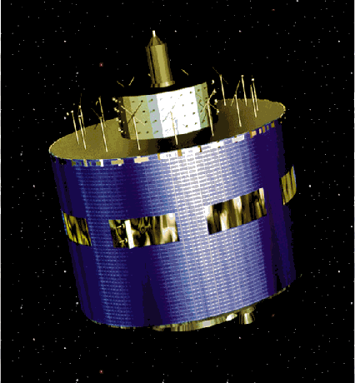
Figure 1. The first MSG satellite was launched in August 2002

caption for Figure 2:
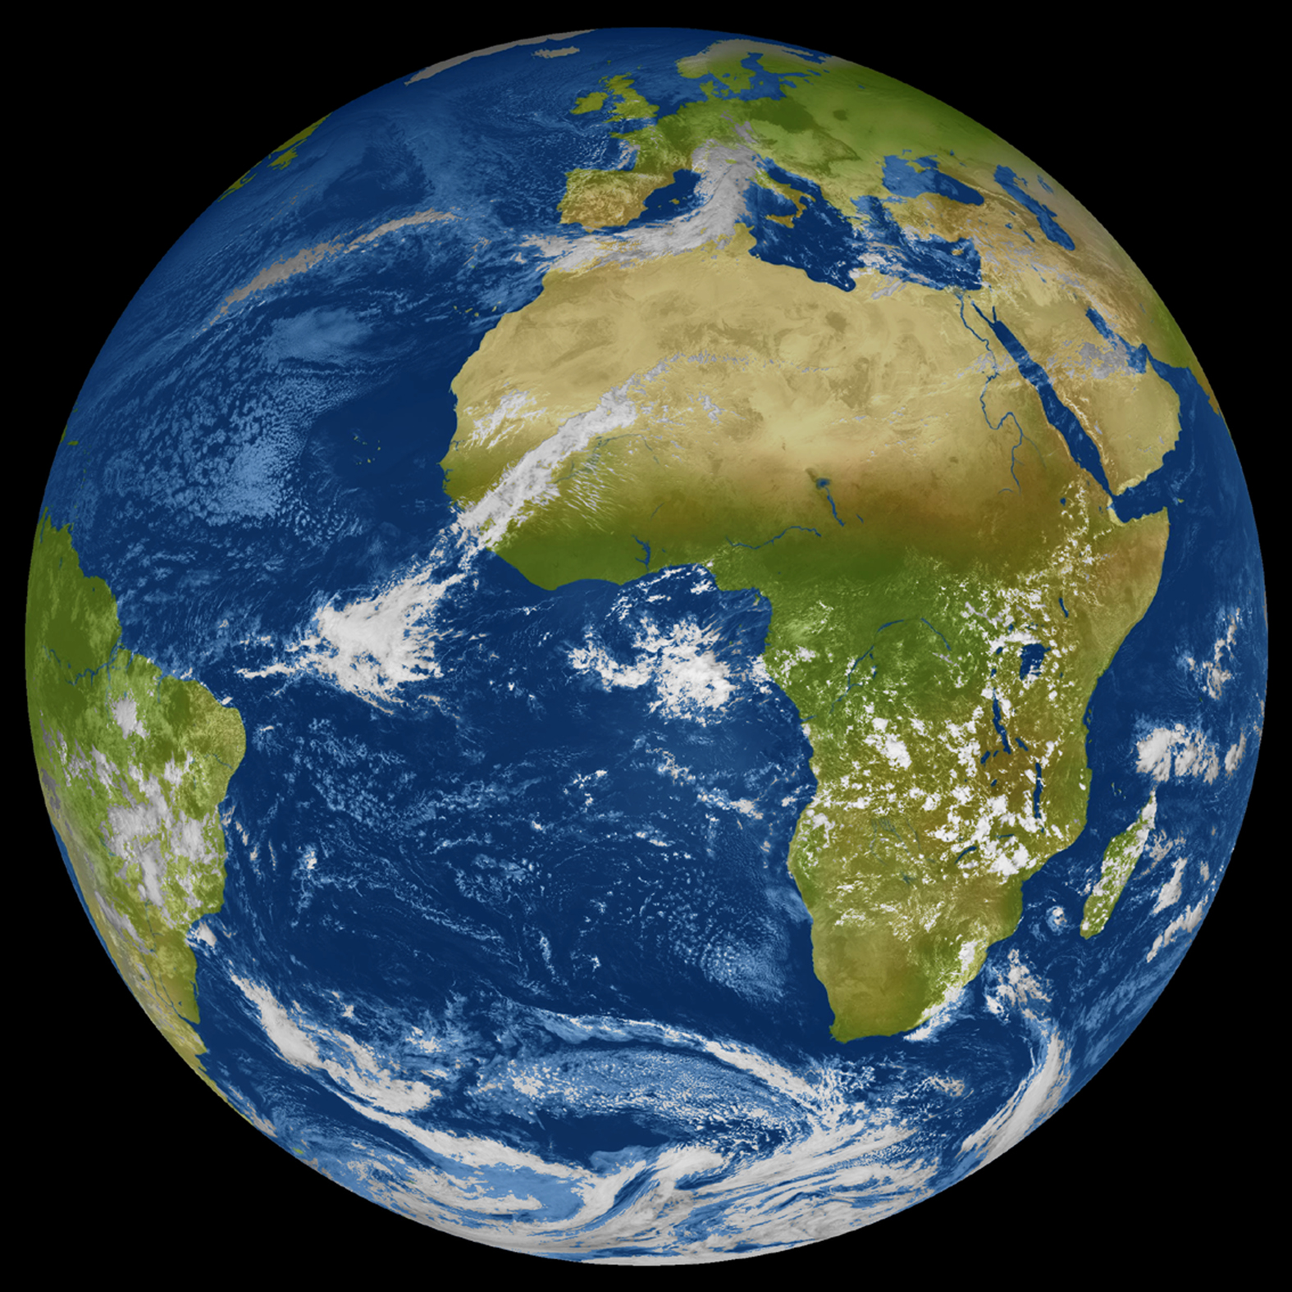
Figure 2. Coverage area of 12-channel imager when satellite is in its nominal position at 0 degrees longitude. The full disk image has 3,712 x 3,712 pixels. The high resolution visible channel image (right panel) covers only half of the Earth in an east-west direction with 11,136 x 5,568 pixels, however the area of imaging can be selected.

caption for Figure 3:
Figure 3
Figure 3a. MSG SEVIRI spectral response functions for the solar channels plotted with the spectral reflectance of vegetation (green) and bare soil (brown) and the spectral irradiance at the top of the atmosphere (red).
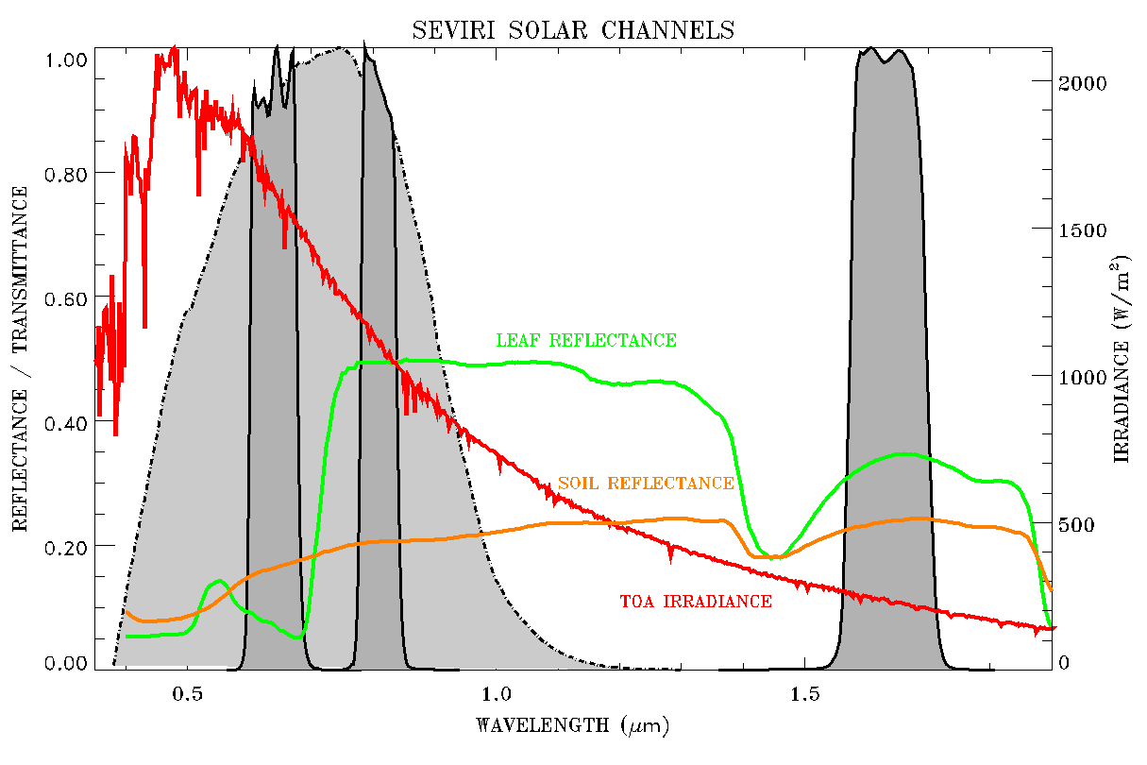

Figure 3b. Thermal terrestrial spectrum and MSG SEVIRI spectral response functions for the thermal channels.
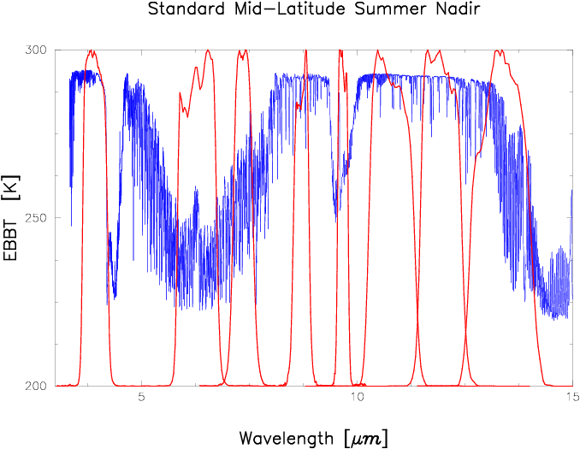

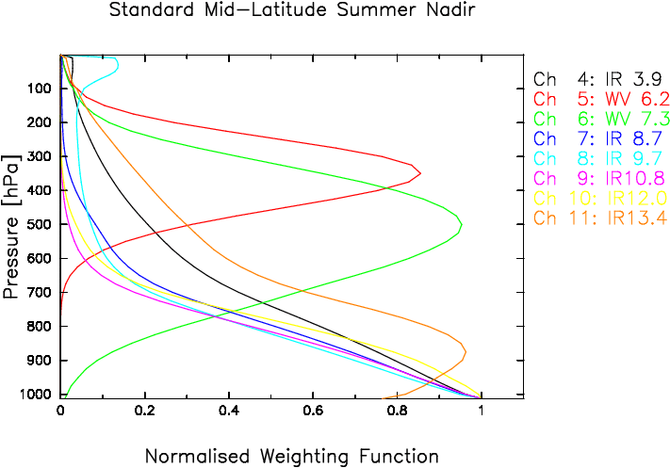
Figure 3c. Weighting functions for the MSG SEVIRI thermal channels, i.e. channels 4 to 11, for a satellite nadir view. A mid-latitude summer standard atmosphere has been assumed for the simulation with a radiative transfer model.
Figure 3d. As for Figure 3c except that the satellite viewing angle is 60°.
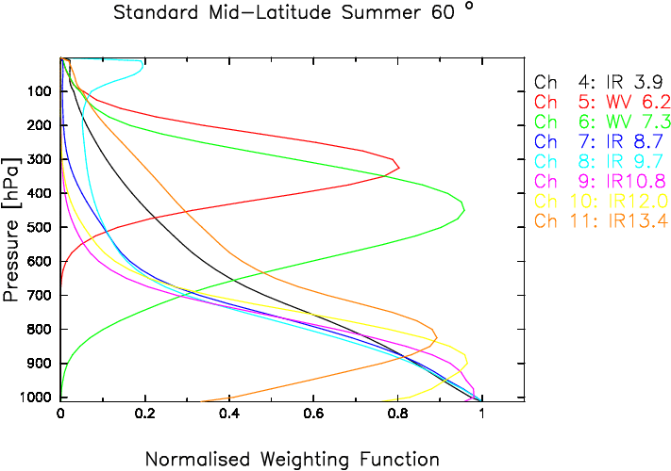

caption for Figure 4:
Figure 4. An image from the first of the MSG satellites. Three spectral channels (at 0.6, 0.8 and 1.6 μm) are assigned to blue, green and red, respectively. Ice clouds appear in blue because these clouds reflect less solar radiation at 1.6 μm than clouds made of water.

